**PROJECT REPORT**

**TITLE:**

Brightness Control using hand detection using OpenCV in PYTHON

**CONTENT:**

* Introduction
* Objectives
* Components
* Methodology
* Future advancement
* Conclusion
* References

**INTRODUCTION:**

With the help of various libraries such as Mediapipe and OpenCV found on PYTHON, a technology can be created with the help of which the brightness of our systems can be increased or decreased as per our requirement. This technology will use computer vision techniques to detect hand gestures and accordingly make required changes in the system.

**OBJECTIVE**:

The main goal of the project is to create a hands-free, intuitive and interactive technology for controlling and managing the brightness level of your system unlike the same traditional methods which can be used in situations where manually changing brightness can be difficult or even life-threatening like while driving.

**COMPONENTS**:

1. Python: It is a high-level programming language used for data analysis, data visualization and facilitate seamless working with OpenCV.
2. OpenCV: This Python library is used for image processing and detecting the hand gestures. OpenCV provides a number of features including Face recognition, tracking and object detection.
3. Mediapipe: One of the well-known Python library used for hand detection and can run on ios, android as well as web browser.
4. Brightness Control Algorithm: An Algorithm is created that understands the hand gestures of the users and then modify the system brightness according to it.

**METHODOLOGY**:

1. Hand Detection: Using object detection and tracking features of OpenCV library, the system detects and then tracks the user’s hand in real time.
2. Gesture Recognition: An algorithm is created to understand the user’s hand gestures and then implement the respective task thus differentiating between a number of commands.
3. Brightness Adjustment: Brightness is adjusted free- handedly and dynamically by recognizing and implementing the user’s hand gestures.

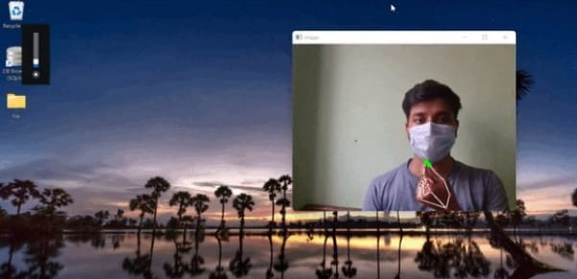

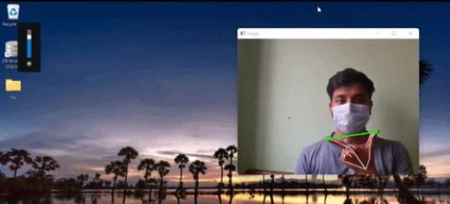

**FUTURE ADVANCEMENTS:**

This technology can be improved and used in a number of different fun and creative ways. Algorithm for brightness adjustment can be refined and can be expanded for more recognized gestures to make smarter devices. One of them can be sound controlling using hand gestures.

**CONCLUSION:**

To conclude our project, Implementing Brightness Control using hand gestures is a fascinating and interactive approach to manipulating image or display settings. However, it comes with its set of benefits and challenges. When done effectively, it can provide an innovative and user friendly way to interact with displays and images, enhancing the overall user experience.

**REFERENCES:**

* https://docs.opencv.org/4.x/d9/df8/tutorial_root.html
* <https://www.geeksforgeeks.org/brightness-control-with-hand-detection-using-opencv-in-python/>
* <https://www.mygreatlearning.com/blog/opencv-tutorial-in-python/>
* <https://github.com/i5han2/Volume_and_Brightness_Control_Using_Hand_Gestures>